CA1

**Name:** Jerusha Angel K

**Register No:**727721EUCS049

Question-1

PROGRAM:-

**package** com.ca1;

**import** org.openqa.selenium.By;

**import** org.openqa.selenium.JavascriptExecutor;

**import** org.openqa.selenium.Keys;

**import** org.openqa.selenium.WebDriver;

**import** org.openqa.selenium.WebElement;

**import** org.openqa.selenium.chrome.ChromeDriver;

**import** org.openqa.selenium.chrome.ChromeOptions;

**import** io.github.bonigarcia.wdm.WebDriverManager;

**public** **class** Question1 {

**public** **static** **void** main(String[] args) **throws** InterruptedException {

// **TODO** Auto-generated method stub

WebDriverManager.*chromedriver*().setup();

ChromeOptions co=**new** ChromeOptions();

co.addArguments("--remote-allow-origins=*");

WebDriver driver=**new** ChromeDriver(co);

driver.get("https://www.amazon.in/?ext_vrnc=hi&tag=googhydrabk1-21&ref=nav_signin&adgrpid=61666692631&hvpone=&hvptwo=&hvadid=486447282128&hvpos=&hvnetw=g&hvrand=6549569956716770192&hvqmt=e&hvdev=c&hvdvcmdl=&hvlocint=&hvlocphy=1007810&hvtargid=kwd-304880464215&hydadcr=14450_2154367");

Thread.*sleep*(2000);

driver.manage().window().maximize();

System.***out***.println("Page Title: "+ driver.getTitle());

String ptitle="Online Shopping site in India: Shop Online for Mobiles, Books, Watches, Shoes and More - Amazon.in";

**if**(driver.getTitle().equals(ptitle)) {

System.***out***.println("Page Title is Valid");

}

**else** {

System.***out***.println("Page Title is Invalid");

}

WebElement c1=driver.findElement(By.*xpath*("//*[@id=\"nav-link-accountList\"]"));

c1.click();

Thread.*sleep*(2000);

WebElement c2=driver.findElement(By.*xpath*("//*[@id=\"ap_email\"]"));

c2.sendKeys("919342806013");

Thread.*sleep*(2000);

WebElement c3=driver.findElement(By.*xpath*("//*[@id=\"continue\"]"));

c3.click();

Thread.*sleep*(2000);

WebElement c4=driver.findElement(By.*xpath*("//*[@id=\"ap_password\"]"));

c4.sendKeys("jerusha2003");

Thread.*sleep*(2000);

c4.sendKeys(Keys.***ENTER***);

WebElement c5=driver.findElement(By.*xpath*("//*[@id=\"twotabsearchtextbox\"]"));

c5.sendKeys("Mirrors");

c5.sendKeys(Keys.***ENTER***);

Thread.*sleep*(2000);

JavascriptExecutor js=(JavascriptExecutor)driver;

js.executeScript("window.scrollBy(0,300)","");

WebElement c6=driver.findElement(By.*xpath*("//*[@id=\"search\"]/div[1]/div[1]/div/span[1]/div[1]/div[9]/div/div/div/div/div[3]/div[1]/h2/a"));

c6.click();

Thread.*sleep*(3000);

driver.navigate().to("https://www.amazon.in/Bikri-Kendra-Hexagon-Acrylic-Stickers/dp/B08S7PC15N/ref=sr_1_7?keywords=Mirrors&qid=1683193316&sr=8-7");

Thread.*sleep*(2000);

// js.executeScript("window.scrollBy(0,100)","");

WebElement c7=driver.findElement(By.*xpath*("//*[@id=\"add-to-cart-button\"]"));

c7.click();

Thread.*sleep*(2000);

driver.navigate().to("https://www.amazon.in/cart/smart-wagon?newItems=98dddcde-5b87-4a82-a157-1c3acdf07a88,5&ref_=sw_refresh");

WebElement c8=driver.findElement(By.*xpath*("//*[@id=\"nav-cart\"]"));

c8.click();

Thread.*sleep*(2000);

String a="https://www.amazon.in/gp/cart/view.html?ref_=nav_cart";

String b=driver.getCurrentUrl();

**if**(a.equals(b)) {

System.***out***.println("Can Be Added To Cart.");

}

**else** {

System.***out***.println("Failed To Add To Cart");

}

WebElement c9=driver.findElement(By.*xpath*("//*[@id=\"a-autoid-0\"]/span"));

c9.click();

Thread.*sleep*(2000);

WebElement c11=driver.findElement(By.*xpath*("//*[@id=\"quantity_3\"]"));

c11.click();

Thread.*sleep*(1000);

String e="https://www.amazon.in/gp/cart/view.html?ref_=nav_cart";

String f=driver.getCurrentUrl();

**if**(e.equals(f)) {

System.***out***.println("Updated");

}

Thread.*sleep*(2000);

String c13=driver.findElement(By.*xpath*("//*[@id=\"sc-subtotal-amount-buybox\"]/span")).getText();

// c9.click();

// Thread.sleep(2000);

// WebElement c10=driver.findElement(By.xpath("//*[@id=\"quantity_0\"]"));

// c10.click();

// Thread.sleep(2000);

// String c="https://www.amazon.in/gp/cart/view.html?ref_=nav_cart";

// String d=driver.getCurrentUrl();

// if(c.equals(d)) {

System.***out***.println("Removed!");

// }

WebElement c12=driver.findElement(By.*xpath*("//*[@id=\"sc-buy-box-ptc-button\"]/span/input"));

c12.click();

Thread.*sleep*(2000);

String g="https://www.amazon.in/gp/buy/addressselect/handlers/display.html?_from=cheetah";

String h=driver.getCurrentUrl();

**if**(g.equals(h)) {

System.***out***.println("Success!");

}

System.***out***.println(c13);

}

}

OUTPUT:-

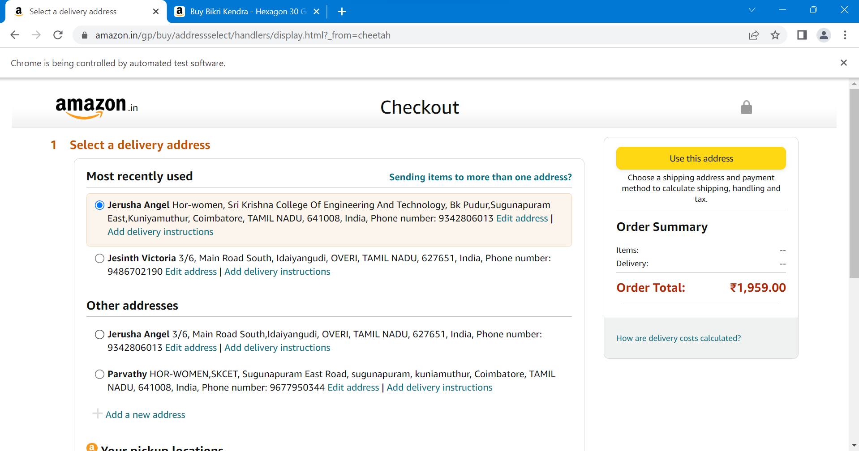

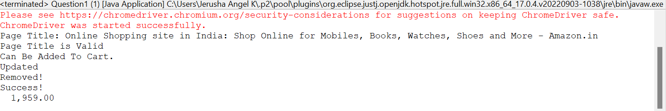

Question-2

PROGRAM:-

**package** com.ca1;

**import** java.util.List;

**import** org.openqa.selenium.By;

**import** org.openqa.selenium.Keys;

**import** org.openqa.selenium.WebDriver;

**import** org.openqa.selenium.WebElement;

**import** org.openqa.selenium.chrome.ChromeDriver;

**import** org.openqa.selenium.chrome.ChromeOptions;

**import** io.github.bonigarcia.wdm.WebDriverManager;

**public** **class** Question2 {

**public** **static** **void** main(String[] args) **throws** InterruptedException {

// **TODO** Auto-generated method stub

WebDriverManager.*chromedriver*().setup();

ChromeOptions co=**new** ChromeOptions();

co.addArguments("--remote-allow-origins=*");

WebDriver driver=**new** ChromeDriver(co);

driver.get("https://www.amazon.in/?ext_vrnc=hi&tag=googhydrabk1-21&ref=nav_signin&adgrpid=61666692631&hvpone=&hvptwo=&hvadid=486447282128&hvpos=&hvnetw=g&hvrand=6549569956716770192&hvqmt=e&hvdev=c&hvdvcmdl=&hvlocint=&hvlocphy=1007810&hvtargid=kwd-304880464215&hydadcr=14450_2154367");

Thread.*sleep*(2000);

driver.manage().window().maximize();

System.***out***.println("Page Title: "+ driver.getTitle());

String ptitle="Online Shopping site in India: Shop Online for Mobiles, Books, Watches, Shoes and More - Amazon.in";

**if**(driver.getTitle().equals(ptitle)) {

System.***out***.println("Page Title is Valid");

}

**else** {

System.***out***.println("Page Title is Invalid");

}

WebElement c1=driver.findElement(By.*xpath*("//*[@id=\"nav-link-accountList\"]"));

c1.click();

Thread.*sleep*(2000);

WebElement c2=driver.findElement(By.*xpath*("//*[@id=\"ap_email\"]"));

c2.sendKeys("919342806013");

Thread.*sleep*(2000);

WebElement c3=driver.findElement(By.*xpath*("//*[@id=\"continue\"]"));

c3.click();

Thread.*sleep*(2000);

WebElement c4=driver.findElement(By.*xpath*("//*[@id=\"ap_password\"]"));

c4.sendKeys("jerusha2003");

Thread.*sleep*(2000);

c4.sendKeys(Keys.***ENTER***);

WebElement c5=driver.findElement(By.*xpath*("//*[@id=\"twotabsearchtextbox\"]"));

c5.sendKeys("Mirrors");

c5.sendKeys(Keys.***ENTER***);

Thread.*sleep*(2000);

List <WebElement> clth=driver.findElements(By.*className*("a-size-mini a-spacing-none a-color-base s-line-clamp-4"));

**for**(WebElement w:clth) {

String y=w.getText();

System.***out***.println(y);

}

WebElement w1=driver.findElement(By.*xpath*("//*[@id=\"a-autoid-0\"]/span/i"));

w1.click();

Thread.*sleep*(2000);

WebElement w2=driver.findElement(By.*xpath*("//*[@id=\"s-result-sort-select_2\"]"));

w2.click();

}

}

OUTPUT:-

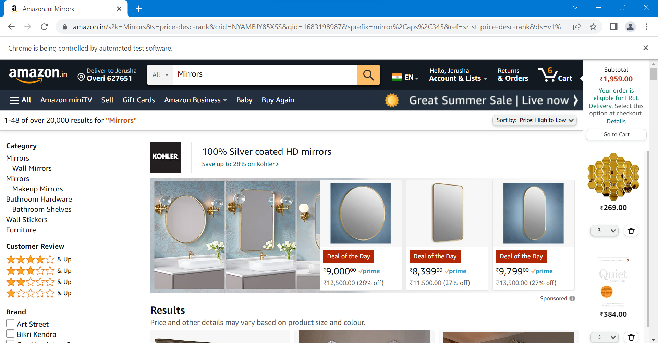

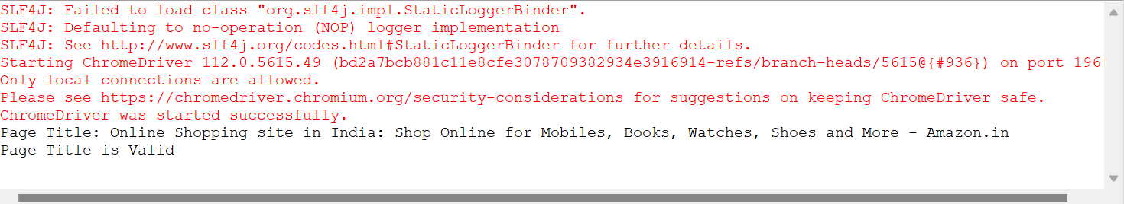

Question-3

PROGRAM:-

**package** com.ca1;

**import** org.openqa.selenium.By;

**import** org.openqa.selenium.Keys;

**import** org.openqa.selenium.WebDriver;

**import** org.openqa.selenium.WebElement;

**import** org.openqa.selenium.chrome.ChromeDriver;

**import** org.openqa.selenium.chrome.ChromeOptions;

**import** io.github.bonigarcia.wdm.WebDriverManager;

**public** **class** Question3 {

**public** **static** **void** main(String[] args) **throws** InterruptedException {

// **TODO** Auto-generated method stub

WebDriverManager.*chromedriver*().setup();

ChromeOptions co=**new** ChromeOptions();

co.addArguments("--remote-allow-origins=*");

WebDriver driver=**new** ChromeDriver(co);

driver.get("https://www.amazon.in/?ext_vrnc=hi&tag=googhydrabk1-21&ref=nav_signin&adgrpid=61666692631&hvpone=&hvptwo=&hvadid=486447282128&hvpos=&hvnetw=g&hvrand=6549569956716770192&hvqmt=e&hvdev=c&hvdvcmdl=&hvlocint=&hvlocphy=1007810&hvtargid=kwd-304880464215&hydadcr=14450_2154367");

Thread.*sleep*(2000);

driver.manage().window().maximize();

System.***out***.println("Page Title: "+ driver.getTitle());

String ptitle="Online Shopping site in India: Shop Online for Mobiles, Books, Watches, Shoes and More - Amazon.in";

**if**(driver.getTitle().equals(ptitle)) {

System.***out***.println("Page Title is Valid");

}

**else** {

System.***out***.println("Page Title is Invalid");

}

WebElement c1=driver.findElement(By.*xpath*("//*[@id=\"nav-link-accountList\"]"));

c1.click();

Thread.*sleep*(2000);

WebElement c2=driver.findElement(By.*xpath*("//*[@id=\"ap_email\"]"));

c2.sendKeys("919342806013");

Thread.*sleep*(2000);

WebElement c3=driver.findElement(By.*xpath*("//*[@id=\"continue\"]"));

c3.click();

Thread.*sleep*(2000);

WebElement c4=driver.findElement(By.*xpath*("//*[@id=\"ap_password\"]"));

c4.sendKeys("jerusha2003");

Thread.*sleep*(2000);

c4.sendKeys(Keys.***ENTER***);

WebElement c5=driver.findElement(By.*xpath*("//*[@id=\"twotabsearchtextbox\"]"));

c5.sendKeys("Mirrors");

c5.sendKeys(Keys.***ENTER***);

Thread.*sleep*(2000);

// WebElement c6=driver.findElement(By.xpath(""));

driver.findElement(By.*xpath*("//*[@id=\"nav-link-accountList\"]")).click();

driver.findElement(By.*xpath*("//*[@id=\"a-page\"]/div[2]/div/div[2]/div[1]/a/div/div")).click();

driver.findElement(By.*xpath*("//*[@id=\"a-autoid-2-announce\"]")).click();

driver.findElement(By.*xpath*("//*[@id=\"ordersInPackage-container\"]/div/div/a[1]")).click();

Thread.*sleep*(2000);

}

}

OUTPUT:-

